WIMMERA PRIMARY CARE PARTNERHIP
DRUG & ALCOHOL FORUM
NOVEMBER 2003



NOVEMBER 5th 2003

FORUM REPORT

Wimmera Primary Care Partnership

Phone: 5382 7660
Fax: 5382 4801

Email: pcpadmin@wimmera.unitingcare.org.au

50c Pynsent Street
PO Box 442
Horsham 3402

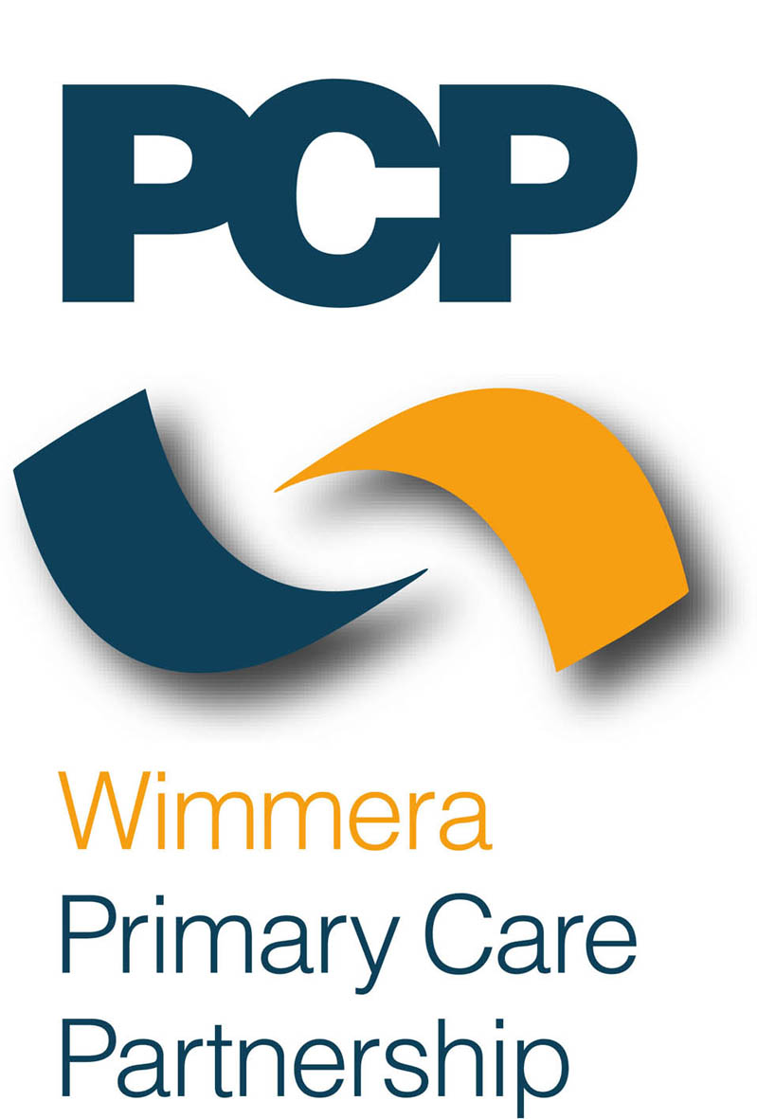

This report provides an outline of the Wimmera Primary Care Partnership 2003 Drug and Alcohol Forum and includes suggested outcomes by participants to enhance drug and alcohol service delivery in the Wimmera sub region. The Wimmera Primary Care Partnership Drug & Alcohol Working Group will utilize the outcomes of the forum to identify its key action tasks for 2003-2004.

Facilitators

Lee Cooper – Tribal Youth & Debbie Milgate Wimmera PCP

Attendees – Refer Appendix One.

Welcome
Debbie Milgate Health Promotion Coordinator and facilitator of the Wimmera Primary Care Partnership Drug and Alcohol working group welcomed all in attendance and provided an overview of the purpose of the Forum, which included the following key points.

- To identify priority drug and alcohol issues for the Wimmera.
- To provide a forum to share information on state and local drug and alcohol initiatives and identify gaps in referral pathways, service availability and delivery.
- To enhance communication between drug & alcohol service providers, primary care agencies and consumers.
The Terms of Reference for the Drug & Alcohol working party and the regions action plan are included in the report.

The keynote speaker - Professor Olaf H Drummer PhD MRACI ARCPA
Subject “Human Cost of Drug and Alcohol Usage on Our Communities”

Please find attached a copy of Professor Olaf H Drummer’s report for full details Appendix two

Professor Drummer provided an excellent overview of drug usage trends and availability
In conclusion he stressed that Community awareness was paramount in prevention and early detection of drug usage. Awareness of family, health professionals, friends – knowledge and alertness of early signs and knowledge of who to contact for assistance and support is vital.

Part 2.

Local Service providers were invited to offer 10-minute snapshot sessions presenting their interpretation of:

- The broader health issues/ causative factor that are leading people to turn to D & A.
- Through their experience, what their agency consider to be priority D & A issues for the region.
- Actions or strategies they would make a difference or address the issues.

In summary -

Horsham Police – Michael Slater
Alcohol is a big problem in the Wimmera and causes a lot of work for the police. Police are currently looking at how to address the problem of alcohol in the youth. Police are making sure that they attend all meetings and talk to the youth to get a full picture of how to go about helping reduce the problem and preventing binge drinking.

Police have found that burglary rates have increased due to drug & alcohol problems. People are stealing to pay for their habits.

Psych Services - Leigh Skewes
Likely presentation of clients is aged from 16 to 65 years of age.
Summit Clinician Tasks
- Best practice service development
- I work through people who don’t go through psych services

Some people take drugs on long term basis to kill pain, feel good about themselves, use drugs just to feel normal, the psyche pain, trouble breathing
Other people take drugs to feel better to look after anxiety and haven’t learnt to cope with this; poor role models so haven’t learnt to deal with drugs probably

Need to look at having a withdrawal nurse, and more councillors – numbers of users going up, actions and strategies address issues, go with them with empathy and hope – don’t have to agree but can understand and give them hope that things can change
All have good skills, use a good as can and teach them the same
Noted funding as difficult – outreach services most acceptable to these clinets

Prevention-

Nexus – Christine Harrison
Issue that young people feel unconnected to their community – grave being valued
Alcohol – belief, this is the only way we can have fun – build confidence
Role model – parents and grandparents who use, teachers, youth workers are using
Educate parents/community
Unemployment – issues that families are facing
Belief that there is nothing to do in the Wimmera
Parents – no boundaries – teenage time rebellious, parents are now asking for more help
Young people believe that they can’t do anything to change

Department of Education & Training - Carlo Ticchi
Youth in schools
Students at risk/learning difficulties across the Wimmera
Getting pissed is getting pathetic
Poor role models – community acceptance of alcohol use i.e. Melbourne Cup – after event
Turn to alcohol belonging, ease pain, socially, shy
Anecdotally – a lot more kids coming through with depression
More calls from schools
Parental attitude – kids being supportive
Good sports program- great model
Boredom – something to do
Comment – young people need to feel more connected

West Vic Division - Jo Martin
Drug and Alcohol not a GP’s priority, that does not mean they are not interested it is one of many health issues that they need to deal with clients
In conversation with GP recognize tobacco as a major health problem more so than alcohol but also recognize the connection of alcohol use to violence
Concerns of GP’s and community
- Cool to be drunk/blame alcohol
- Availability and marketing of cheap alcohol
- Party drugs – not something a lot of doctors know a lot about
- Mixing drugs big issue
- Young woman who are using sexual favors in exchange for alcohol and drugs
- Cannabis is common
- Community and health issues

Good Sports Program - Barry Senior
Prevention and harm minimization role
Working with sport clubs regarding the handling and provision of alcohol
Aims – not dry up sport clubs, an important role in the community, clubs sell alcohol within the law, prevent alcohol related problems, reduce and eliminate drink driving from clubs, provide an ongoing education program
Why sporting clubs – historical partnership with alcohol and sport in Australia, sporting clubs are an important role in the community

Priority D & A issues identified by forum participants following morning presentations:
- Important to enhance moving more into a community development approach
- Big issue is funding – want to take funds to outreach more
- Lack of residential facilities, detox facilities, hard to make client motivated – really struggle
- Priority to raise awareness of support services, recognising at risk people
- Youth team have adopted modeling etc as parents behavior that should be ok
- Support Community connectedness approach – lack of people joining clubs, people bowling alone
- Important to build community connection
- Great collaboration – looking after our mate’s good relationship with police
- Another problem coming out to identify children at a high risk
- Creating conversations - substance use is not the problem – the answer is collaboration

Panel discussion
  - Recreational drug use verse’s addicts
  - Is the exposure and knowledge higher – getting bored a lot quicker
  - Changing family structure is creating increased issues – reduced role models, loss of connection to extended families
  - Does anyone know of a formal buddy system with kids – peer support program in Adelaide
  - Discipline restraints limit response
  - Needy box – single parent families etc are the users
  - Research – it’s a disease, not for everyone, there are different users for different reasons

Afternoon workshops

Simultaneous WORKSHOPS – Presentation and discussion
Participants selected workshop
- Alcohol & Drug Causal factors – Palm Lodge Thea Farrington
- Media portrayal of alcohol “The Bundy bear & brad verses the anti drinking ads” – Lee Cooper / Barry Senior
- Psychological factors – Dual diagnosis Leigh Skewes
(4) Crime outcomes Laurie Thomas

Conclusion – Lee Cooper summarized the day’s outcomes
Parents – are we blaming them
Young people so influenced, positive etc family is a really important thing – they are a big part of the solution
Connectiveness – reconnect areas such as sporting groups etc
Differences of opinion – disease psychological etc, these don’t keep us apart
Similarities, holistic approach – no one person has a responsibility to improve the situation
Tribal youth – looks to make that one-drop of difference, ripples will feed each other

Debbie – Strategies from forum
Discussion and consensus of the priority outcomes
- Development of a referral pathways flowchart
- Parenting – resource provision
- Building Inclusive communities- scout groups, choirs, mentoring programs (? Sub committee)
- Service gaps - Withdrawal service / outreach service
Tasks for Drug and Alcohol working group

Drug and alcohol – community building and community connectiveness
Look at parenting services
Identifying services – what drug and alcohol services lacking in the area e.g. hospital in the home

Final Outcome – already under development

Developing drug and alcohol website – link to local providers as well as some outside the region and connecting care

RELEVANT SERVICE PROVIDERS

Alcoholics Anonymous
PO Box 133
Horsham 3402
Ballarat 5334488

Nar-Anon Family Groups
C/- PO Box 985, Horsham. VIC. 3402.
Phone: 03 5382 2036
Email: driscon@netconnect.com.au

Narcotics Anonymous
C/- PO Box 985, Horsham. VIC. 3402.
Phone: 03 5382 1993

Goolum Goolum Aboriginal Cooperative
Droylesden, 143 - 145 Baillie St, Horsham. VIC. 3400.
(PO Box 523, Horsham. VIC. 3402.)
Phone: 03 5382 5033 Fax: 03 5381 1563
Email: craiggoolum@bigpond.com

Grampians Community Health Centre
Palm Lodge
25 David St, Horsham. VIC. 3400.
(PO Box 501, Horsham. VIC. 3402.)
Phone: 03 5381 1062 Fax: 03 5382 4687
Email: plodge@gchc.org.au

"Serving the Wimmera"

Wimmera Uniting Care
ABN: 03 638 645 369
185 Baillie St, Horsham. VIC. 3400.
(PO Box 442, Horsham. VIC. 3402.)
Phone: 03 5382 6789 Fax: 03 5382 1566
Email: info@wimmera.unitingcare.org.au

Mission
Supporting and strengthening personal, family and community life throughout the Wimmera.

ALCOHOL & DRUGS
24 hour Telephone & Counselling& Referral Service
Country Free call 1800 136 385

Rodney Soar, SUMITT (Substance Use and Mental Illness Treatment Team) Clinician
- Persons diagnosed with a serious mental illness and misuse licit/illicit drugs, which cause instability.
Janice Rowan, Team Leader, Primary Mental Health Support Team
- Primary care service providers delivering services to consumers with high prevalence mental disorders or to youth art risk of severe psychological disturbance.

West Vic Division of General Practice – More Allied Health Service Program
Dr Rob Grenfell, GP Consultant
- Patients of Wimmera and Maryborough GP’s
Community Axis
Janet Heard, Employment Services Manager
- Any person between age 15-65 wanting employment assistance and endorsement by Centrelink.
Carers Choice, Ballarat Health Services

Centacare, Catholic Diocese of Ballarat Inc
Lindy Mullar, DASH Program
- People who have complex and multiple needs and live in low cost or insecure accommodation or are homeless or at risk of homelessness.
Ivan Thorne, Team Leader, MASC Residential Rehabilitation Program
- Young people aged primarily 18-24 who have a mental illness or are assessed as at risk of developing a mental illness with high-risk behaviors.

WIMMERA PRIMARY CARE PARTNERSHIP

DRUG & ALCOHOL WORKING PARTY

TERMS OF REFERENCE

BACKGROUND

As a result of recommendations made in the final report of the Drug Policy Expert Committee (DPEC), the Victorian Government has approved four key strategies to approach the drug crisis. These strategies are:

- Preventing drug abuse
- Reducing harm and saving lives
- Getting lives back on track
- Effectively policing the drug trade
These should therefore inform the actions of local Drug and Alcohol Working Party

PURPOSE

To provide a forum to build a partnership between key stakeholders within the Wimmera Sub Region with respect to the development of drug and alcohol promotion and service delivery to people affected by the impact of the use of these substances.

OBJECTIVES

As stated in the DPEC Report, it is essential that communities take actions to address local drug problems that are appropriate to the specific needs of each community. Data from the Wimmera alcohol and drug service (Palm Lodge Centre) as well as anecdotal evidence from numerous small communities in the Wimmera region, indicates that irresponsible consumption of alcohol is seen as the most significant drug problem in the Wimmera. Evidence indicates that the underlying causes of substance abuse can be addressed by strengthening the capacity of community members to understand and respond to local drug issues.

Therefore the objectives of the Wimmera Drug and Alcohol Working Party are to:
- Raise awareness that alcohol is a drug;
- Encourage responsible consumption of alcohol;
- Research issues contributing to irresponsible alcohol consumption by young people in Wimmera communities;
- Develop programs and resources to assist local communities to reduce the incidence of binge drinking.
- Support & implement the Wimmera Drug Action Plan (attached)
STRATEGIES
- Conduct an annual Drug & Alcohol forum to provide to share information on state & local initiatives and identify gaps in referral pathways and services availability and delivery.
- Utilize the outcomes of the Annual Drug & Alcohol Network Forum to recommend strategies for planning and development to the (WPCP) Executive Committee. This information will form the framework of strategies relating to Drugs & Alcohol in the WPCP 2003/2004 and subsequent Community Health Plan.
- Provide a coordinated and partnership approach to strategic planning, development and implementation of Drug & Alcohol health services and initiatives in the Wimmera Region.
- Provide a forum to enable facilitate better communication between Drug & Alcohol health service providers, primary care agencies and consumers.
- Facilitate member agencies engagement in partnership with funding bodies and service providers where opportunities arise
- Facilitate stakeholders to collaboratively plan and seek funding for Drug & Alcohol health promotion and service initiatives and to lobby for change were a gap is identified.
- Ensure that the Service coordination work of the PCP particularly in the area of practices, protocols and procedures reflects and integrates mental health sensitive practice.
- Provide feedback mechanism to inform the development of the Grampians Region Community Mental Health Plan to review current mental health service delivery, identify service needs and provide strategic planning options.
- Facilitate Drug and alcohol workforce development for local workers to raise awareness of issues associated with substance abuse and management.
- Ensure the involvement of key stakeholders in planning, implementation, review and evaluation, including consumers, carers, private practitioners, other relevant service providers and community groups.
- Provide monthly feedback to the WPCP Executive Committee on the progression of the Reference Group.

VALUES

- The Drug & Alcohol working party views positive health and wellbeing as the right of individuals and populations.
- The Drug & Alcohol Working party respects the principles of the action frameworks for the Social Model of Health and the Ottawa Charter.
- The Drug & Alcohol working party recognises and respects the skills of knowledge that exists within our network and its existing infrastructure.
- The Drug & Alcohol working party recognises and respects the values of participating agencies.

WIMMERA PCP DRUG & ALCOHOL WORKING PARTY MEMBERSHIP

Any person with an interest in improving health outcomes for the Wimmera population, including representatives from primary care agencies, community groups and consumers may nominate to participate in the Drug & Alcohol working party

The Wimmera PCP Drug & Alcohol working party aims to have representation from the primary care sector and community. This may include representation from each alliance member, special interest groups such as youth, sports and recreation, neighbourhood Houses, community service agencies and consumer representation.

MEETINGS

Location: meetings are held in Horsham as the regional centre for the Wimmera.

Venue: Currently held at Palm Lodge Centre Horsham.

Meeting Schedule: the Wimmera PCP Drug & Alcohol working party will meet monthly, currently the second Thursday of the month
11.00am – 12.30 (unless otherwise notified)
Does not include lunch unless otherwise notified.

Review of Meetings: Date/time and location of meetings will be reviewed six-monthly.

REPORTING MECHANISMS

Minutes will be taken by members on a rotating basis and collated by the Wimmera PCP.
The Wimmera PCP will circulate the agenda by mail ideally one week the scheduled meeting. Minutes will be issued the week following the meeting.

The Wimmera PCP Executive Committee and alliance members will be informed of the activities of the D & A working party through the PCP reporting structure and the sharing of minutes.

Members will provide feedback to and from their participating agencies and consumers.

CHAIRPERSON

A chairperson will be nominated annually.

August 2003

Current members
- Debbie Milgate Chairperson – Wimmera PCP
- Cath McDonald – Lowan Health Services
- Di Trotter – Wimmera Sports Assembly
- Sg Laurie Thomas – Horsham Police Crime Prevention Officer
- Karen Sanderson – Wimmera Health Care Group
- Jan Spencer – Infection Control – Wimmera Health Care Group
- Chris Solly – Yarriambiack Shire
- Clyde Lourensz – Palm Lodge
- Lee Cooper – Tribal Youth
- Carlo Ticchi – Department of Education & Training
- Kate Driscoll – Na Anon
- Bruno – Alcoholic Anonymous
- Andreana Harrison – Department of Human Service
- Sally Melville Wimmera Uniting Care
- Jan St John – Palm Lodge

WIMMERA PCP A&D WORKING PARTY

LOCAL DRUG ACTION PLAN 2003

- BACKGROUND

As a result of the recommendations made in the final report of the Drug Policy Expert Committee (DPEC), the Victorian Government has approved four key strategies to approach the drugs crisis. These strategies are:
- Preventing drug abuse
- Reducing harm and saving lives
- Getting lives back on track
- Effectively policing the drugs trade.
- OBJECTIVES

As stated in the DPEC Report, it is essential that communities take actions to address local drug problems that are appropriate to the specific needs of each community. Data from the Wimmera alcohol and drug service (Palm Lodge Centre) as well as anecdotal evidence from numerous small communities in the Wimmera region, indicates that irresponsible consumption of alcohol is seen as the most significant drug problem in the Wimmera. Evidence indicates that the underlying causes of substance abuse can be addressed by strengthening the capacity of community members to understand and respond to local drug issues.

Therefore the objectives of the Wimmera Drug action Plan are to:
- Raise awareness that alcohol is a drug;
- Encourage responsible consumption of alcohol;
- Research issues contributing to irresponsible alcohol consumption by young people in Wimmera communities;
- Develop programs and resources to assist local communities to reduce the incidence of binge drinking.

- STRATEGIES

The strategies developed to achieve these objectives are underpinned by the following principles:
  - Harm minimisation, which aims to improve health, social and economic outcomes for both the community and the individual.
  - Social model of health, which focuses on improving the health and well-being of the population through addressing the social, cultural, environmental, biological, political, economic and medical determinants of health.
  - Community strengthening, which includes capacity building through partnerships, a focus on local initiatives, flexible approaches and an emphasis on the development of sustainable strategies.
- Risk and protective factors are considered so that primary prevention and early intervention strategies are more likely to result in connectedness and resilience.
- Links with other planning processes and initiatives to ensure coordination and reduce the potential for duplication.
- Collaboration between key stakeholders to ensure that the views of all community members are represented.
- Evidence based approach to ensure best practice, satisfactory theoretical development, effectiveness and efficiency, cost-effectiveness and a focus on outcomes and outputs.
Feb 2004

